

|  |
| --- |
| Link2Care Agenda |
| Quarter 1 [2023] |
| March 22, 2023: 10:00 AM – 11:00 AM |

# Action Items

|  |
| --- |
| 1. Study Update |
| 1. Placeholder |
|  |
|  |

Contents

Action Items 1

Study Participants 3

Phone and ClinCard Breakdown 4

Phone terminations 5

Visit Compliance 6

COVID -19 7

EMA and Study Completion Rates 8

Arrests 10

Bridge Case Session Minutes 11

Recruitment 12

Link2Care Study Update

**N =** **442 people screened as of** **March 21, 2023**

# Study Participants

**Table 1.** Demographic characteristics of all people screened for study inclusion.

| **Characteristic** | **Screened-in** | **Screened-out** |
| --- | --- | --- |
| **(n = 442)** | **(n = 68)** |
| **Age in years**, mean (sd) | 40.1 (10.8) | 45.2 (11.5) |
|  |  |  |
| **Gender**, n(%) |  |  |
| Male | 374 (84.6) | 60 (88.2) |
| Female | 61 (13.8) | 8 (11.8) |
| Other | 7 (1.6) | 0 (0.0) |
|  |  |  |
| **Race**, n(%) |  |  |
| Black or African American | 273 (61.8) | 52 (76.5) |
| White | 103 (23.3) | 11 (16.2) |
| Other | 66 (14.9) | 5 (7.4) |
|  |  |  |
| **Ethnicity**, n(%) |  |  |
| Non-Hispanic | 390 (88.2) | 66 (97.1) |
| Hispanic | 52 (11.8) | 2 (2.9) |

**Table 2.** Distribution of reasons for screen-out1.

| **Reason For Screen Out** | **n (%)** |
| --- | --- |
| Score <4 on REALM-SF | 54 (79.4) |
| Score <24 on Mini-Mental State Exam | 25 (36.8) |
| Incorrect Consent Reading | 14 (20.6) |
| Failure to Orient | 10 (14.7) |
| Other | 10 (14.7) |
| PT Plans to Move | 3 (4.4) |
| Walked Out Prior to Screen Out | 2 (2.9) |
| Refused to report SSN or residency | 0 (0.0) |

1. The total number of reasons screened out is larger than the total number of participants screened out because participants could be screened-out for more than one reason. Likewise, the percentages in Table 2 sum to great than 100 because the denominator used in the calculation is the total number of participants.

# Phone and ClinCard Breakdown

|  |  |
| --- | --- |
| **Table 3**. Payment card and phone loss. | |
| Total number of ClinCards distributed | 746 |
| Total number of participants with ClinCard replacements | 195 |
| Total number of phones distributed | 419 |
| Total number of participants with phone replacements | 138 |
| Number of participants with 1 replacement card (2 total cards) | 121 |
| Number of participants with 2 replacement card (3 total cards) | 48 |
| Number of participants with 3 replacement card (4 total cards) | 19 |
| Number of participants with 4 replacement card (5 total cards) | 6 |
| Number of participants with 5+ replacement card (6 total cards) | 1 |

|  |  |
| --- | --- |
| **Table 4.** Phone distribution and replacement. |  |
|  | n (%) |
| Total number of phones distributed overall | 419 |
| Total number of participants in phone groups | 269 |
| Total number of participants w/ phone replacements | 138 |
| Total number of participants w/ phone replacement (**UCM+SP**) | 64 |
| Total number of participants w/ phone replacement (**L2C**) | 74 |
| Total number of participants in UCM+SP w/ 1 phone replacement | 57 |
| Total number of participants in L2C w/ 1 phone replacement | 68 |
| Total number of participants in UCM+SP w/ >1 phone replacement | 7 |
| Total number of Participants in L2C w/ >1 phone replacement | 6 |

# Phone terminations

**Figure 1.** Reasons for phone terminations overall (N = 414 terminations).

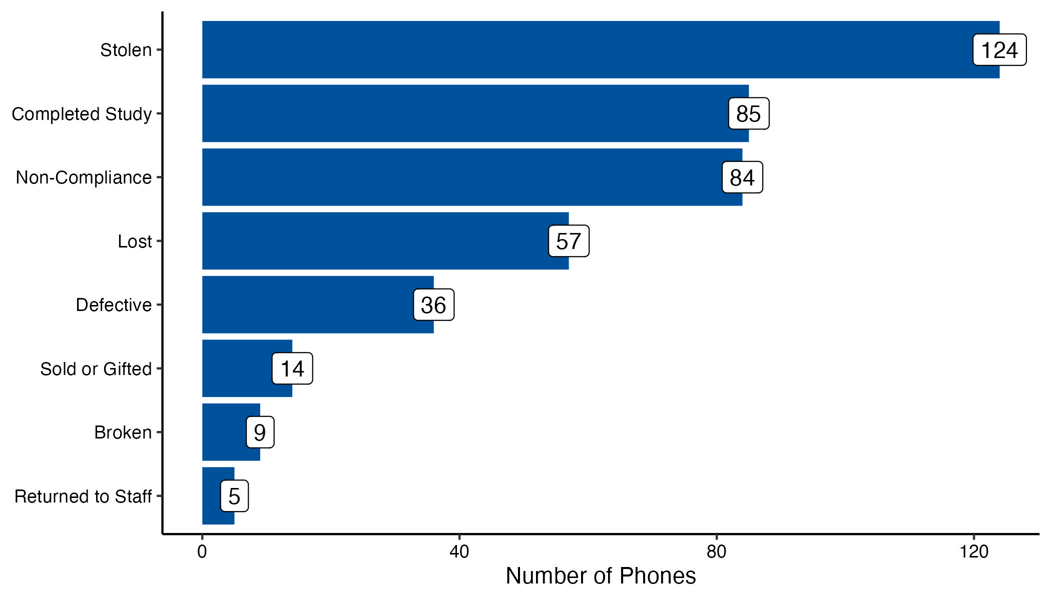

|  |  |  |  |
| --- | --- | --- | --- |
| **Table 5.** Reasons for phone terminations by informed consent form version | | | |
|  | **ICF #1**: Original EMA Structure  (P2001-P2073) | **ICF #2:** 15-Day EMA Comp & Non-compliance  (P2074-2153) | **ICF #3:** Increased EMA Payment  (P2154+) |
| **Reasons for Terminations** | **n (column %)** | **n (column %)** | **n (column %)** |
| Stolen | 33 (42.9) | 27 (32.1) | 64 (25.3) |
| Completed Study | 23 (29.9) | 13 (15.5) | 49 (19.4) |
| Non-Compliance | 0 (0.0) | 18 (21.4) | 66 (26.1) |
| Lost | 13 (16.9) | 15 (17.9) | 29 (11.5) |
| Defective | 2 (2.6) | 9 (10.7) | 25 (9.9) |
| Sold or Gifted | 3 (3.9) | 2 (2.4) | 9 (3.6) |
| Returned to Staff | 0 (0.0) | 0 (0.0) | 5 (2.0) |
| Broken | 3 (3.9) | 0 (0.0) | 6 (2.4) |
| **Total** | **77 (100)** | **84 (100)** | **253 (100.0)** |

# Visit Compliance

|  |  |
| --- | --- |
| **Table 6.** Number and percent of participants per L2C group (n randomized = 406). | |
| **L2C Group** | **n (percent)** |
| UCM+SP | 135 (33.3) |
| UCM | 137 (33.7) |
| L2C | 134 (33.0) |

|  |  |  |
| --- | --- | --- |
| **Table 7.** Number and percent of participants who completed visits 1 through 5. | | |
| **Visit Number** | **Overall**  **N =** **442**  n (percent) | **Participants Who Attended Visit 2**  **N =** **406**  n (percent) |
| 1 | 442 (100.0) | - |
| 2 | 406 (91.9) | 406 (100.0) |
| 3 | 303 (68.6) | 303 (74.6) |
| 4 | 237 (53.6) | 237 (58.4) |
| 5 | 204 (49.2) | 204 (53.8) |
|  |  |  |

# COVID -19

|  |  |
| --- | --- |
| **Table 8**. COVID-19 phone, REDCap, and combination interviews since protocol change on 3/17/2020. | |
|  | Number of Interviews |
| **Overall** | **152** |
| Phone | 59 |
| REDCap | 92 |
| Both | 1 |
| *L2C Groups* |  |
| UCM | 41 |
| UCM+SP | 58 |
| L2C | 53 |
| *L2C Visits* |  |
| Visit 2 | 1 |
| Visit 3 | 45 |
| Visit 4 | 54 |
| Visit 5 | 52 |
| Notes. N=total number of phone interviews conducted. Some participants have had >1 remote interview. | |

# EMA and Study Completion Rates

On 11/21/2018, we changed our approach to compensating participants for completing Ecological Momentary Assessments (EMA).

* Participants 2001-2073 (n = 47) were compensated using initial payment approach.
  + Compensated at visit 3, visit 4, and visit 5.
  + Compensated $10, $15, and $25 for EMA Completion.
* Participants 2074-2152 (n = 49) were compensated more frequently.
  + Frequency of payment was changed to every 15 days.
  + Compensation amounts did not change.
* Participants 2153 and above received doubled compensation rates.
  + Frequency of payments. Remained every 15 days.
  + Compensated $20, $30, and $50 for EMA Completion

**Figure 2.** Number of Ecological Momentary Assessments (EMA) completed by 15-day cycle and payment approach (initial vs revised - combined).

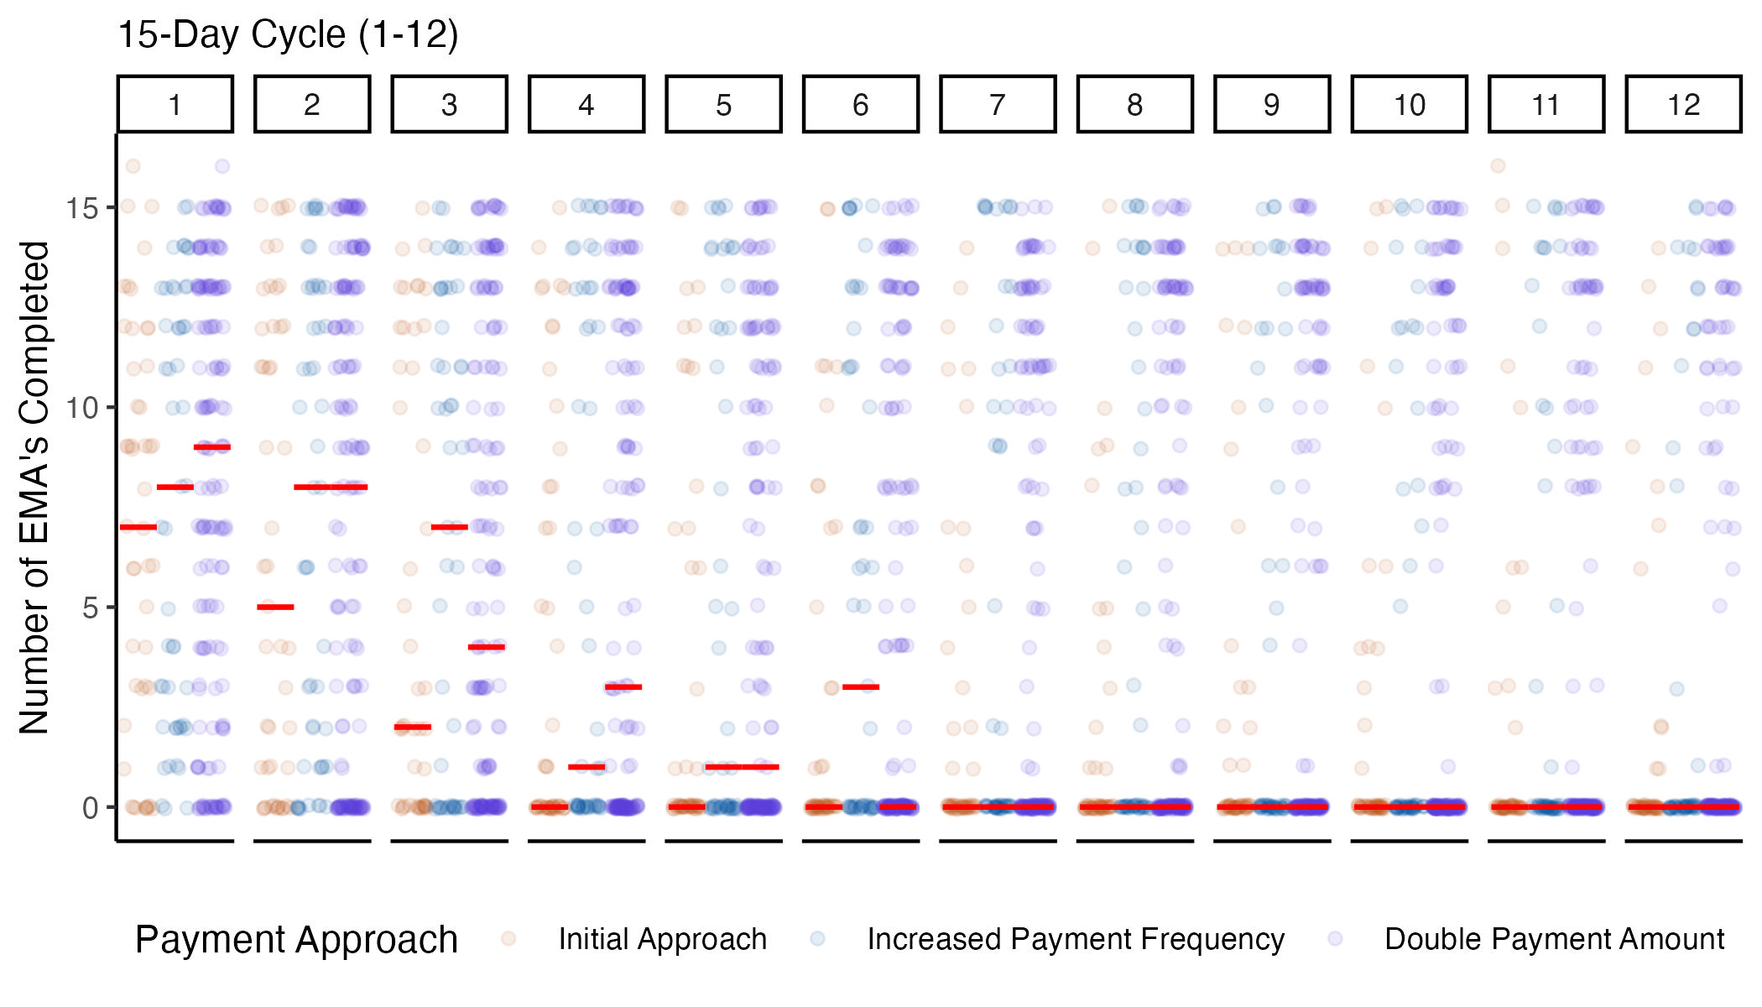

1. Red lines are equal to the median number of EMA's completed for each cycle and pay approach.

**Figure 3.** Percentage of participants who completed zero Ecological Momentary Assessments (EMA) by 15-day cycle and payment approach.

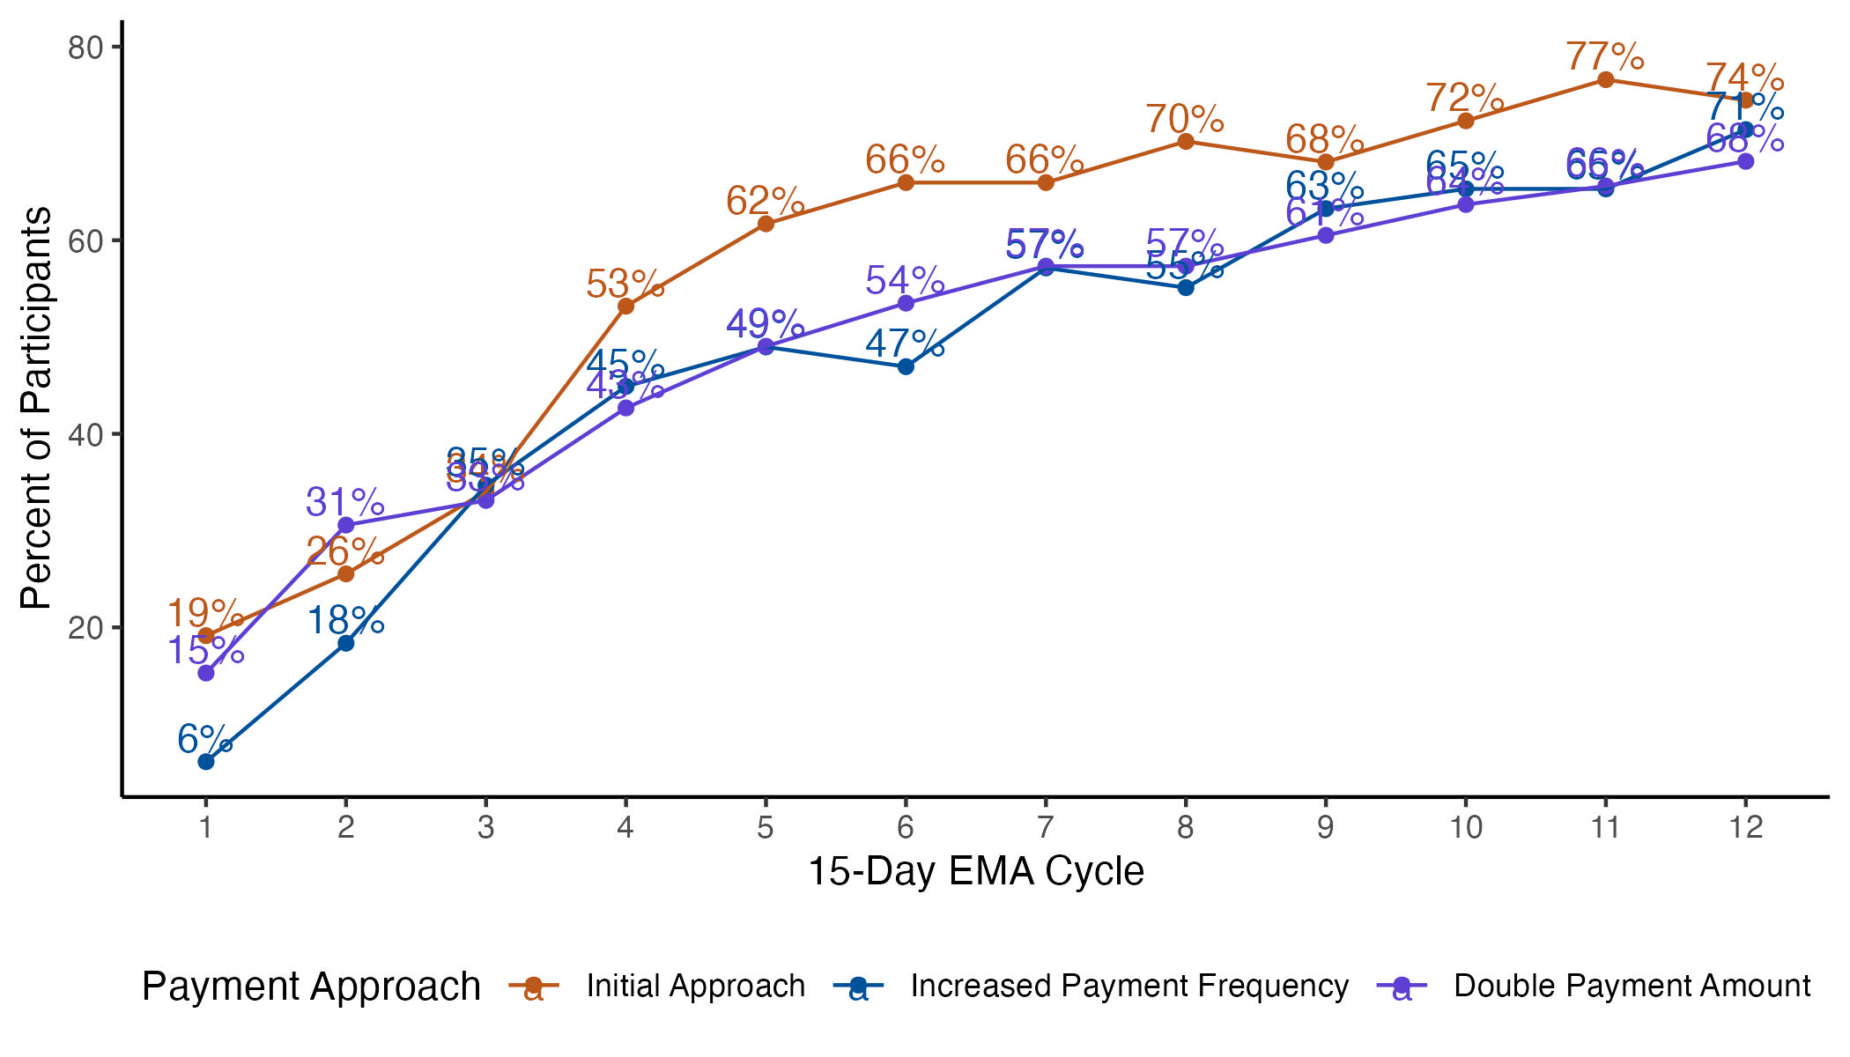

**Figure 4.** Percentage of participants who completed seven or more Ecological Momentary Assessments (EMA) by 15-day cycle and payment approach.

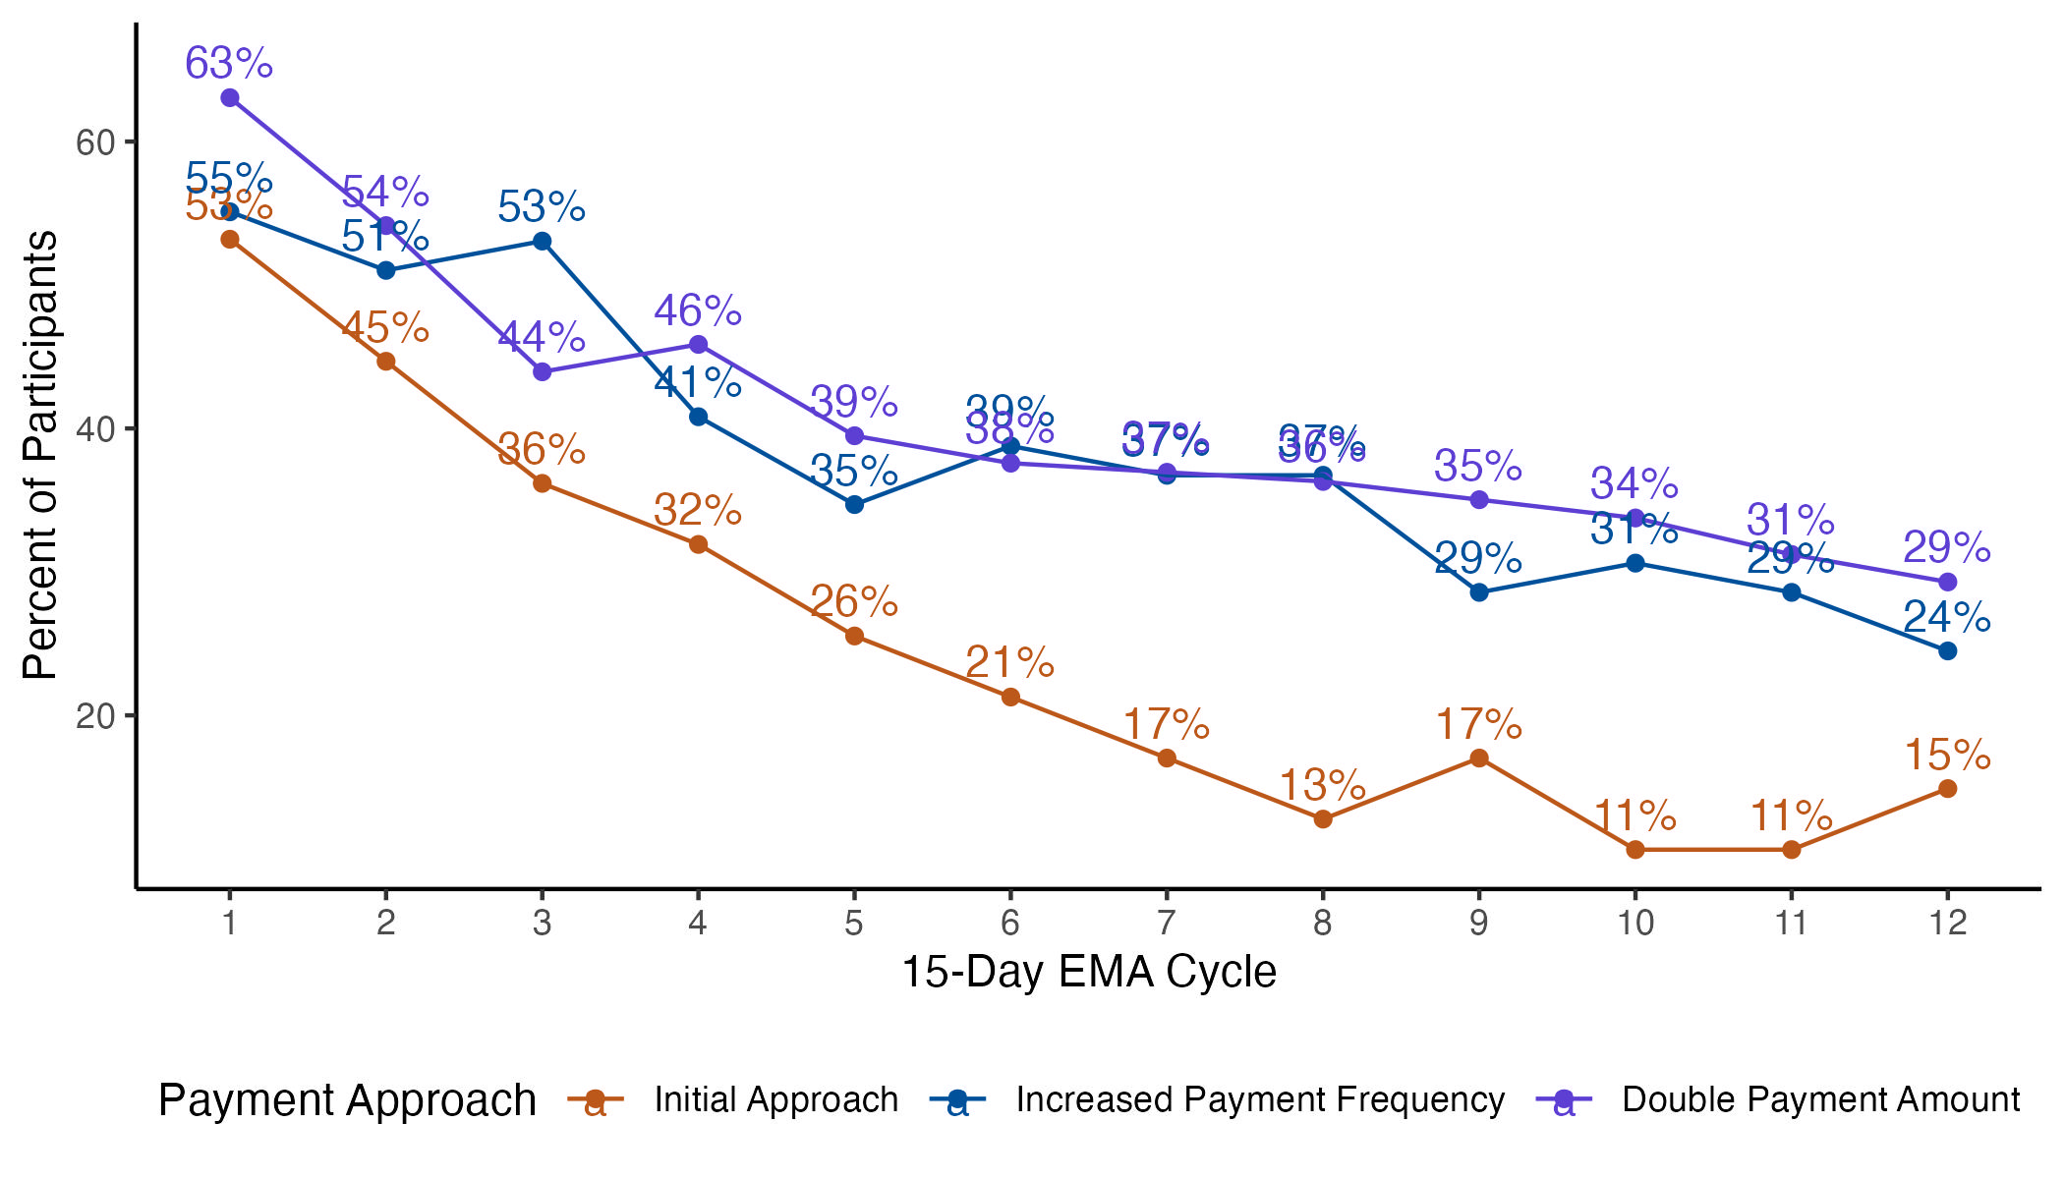

# Arrests

|  |  |  |
| --- | --- | --- |
| **Table 10.** Arrests by treatment arm 12 months after enrollment. | | |
| **Treatment Condition** | **N** | **Arrested**  n (row percent) |
| *Overall* | 349 | 157 (45.0) |
| UCM | 106 | 47 (44.3) |
| UCM+SP | 109 | 51 (46.8) |
| L2C | 107 | 43 (40.2) |
| NS V2 | 27 | 16 (59.3) |
|  | | |

# Bridge Case Session Minutes

|  |  |  |  |  |
| --- | --- | --- | --- | --- |
| **Table 11.** Number and percent of participants who used Bridge case management1 | | | | |
|  | **Number of Participants (%)** | | | |
| **Overall**  **(N=****406)** | **UCM**  **(N=****137)** | **UCM+SP**  **(N=****135)** | **L2C**  **(N=****134)** |
| Used at least one session of regular case management | 302 (74.4) | 106 (77.4) | 96 (71.1) | 100 (74.6) |
| Used at least one session of crisis case management | 37 (9.1) | 14 (10.2) | 13 (9.6) | 10 (7.5) |
| Used at least one session of other case management | 203 (50.0) | 73 (53.3) | 62 (45.9) | 68 (50.7) |
| Used **no** forms of Bridge case management | 86 (21.2) | 25 (18.2) | 33 (24.4) | 28 (20.9) |
| Note: Categories of case management are not mutually exclusive, so percentages may exceed 100.  1. Only includes participants who were randomized to a study arm and have a row in the bridge session minutes. | | | | |

|  |  |  |  |  |  |
| --- | --- | --- | --- | --- | --- |
| **Table 12**. Number and duration of case management sessions used1 | | | | | |
|  | **Overall**  **(N=****406)** | **UCM**  **(N=****137)** | **UCM+SP**  **(N=****135)** | **L2C**  **(N=****134)** | | |
| **Case management of any type** |  |  |  |  | | |
| Sessions per participant, median (range) | 4 (0-66) | 5 (0-66) | 3 (0-57) | 4 (0-54) | | |
| Total minutes of sessions per PT, median (range) | 112 (0-1,910) | 135 (0-1,800) | 100 (0-1,630) | 102 (0-1,910) | | |
| **Regular Case Management** |  |  |  |  | | |
| Sessions per participant, median (range) | 6 (1-48) | 7 (1-46) | 6 (1-47) | 6 (1-48) | | |
| Total minutes of sessions per PT, median (range) | 208 (15-1,845) | 215 (30-1,615) | 185 (20-1,525) | 190 (15-1,845) | | |
| **Crisis Case Management** |  |  |  |  | | |
| Sessions per participant, median (range) | 1 (1-8) | 1 (1-7) | 1 (1-8) | 1 (1-3) | | |
| Total minutes of sessions per PT, median (range) | 35 (10-265) | 35 (10-235) | 45 (10-265) | 30 (10-80) | | |
| **Other Case Management** |  |  |  |  | | |
| Sessions per participant, median (range) | 2 (1-19) | 2 (1-19) | 2 (1-16) | 2 (1-14) | | |
| Total minutes of sessions per PT, median (range) | 10 (2-150) | 10 (5-150) | 15 (2-102) | 10 (5-110) | | |
| 1. Only includes participants who were randomized to a study arm. | | | | |  |

# Recruitment

**Figure 5.** Recruitment by month.

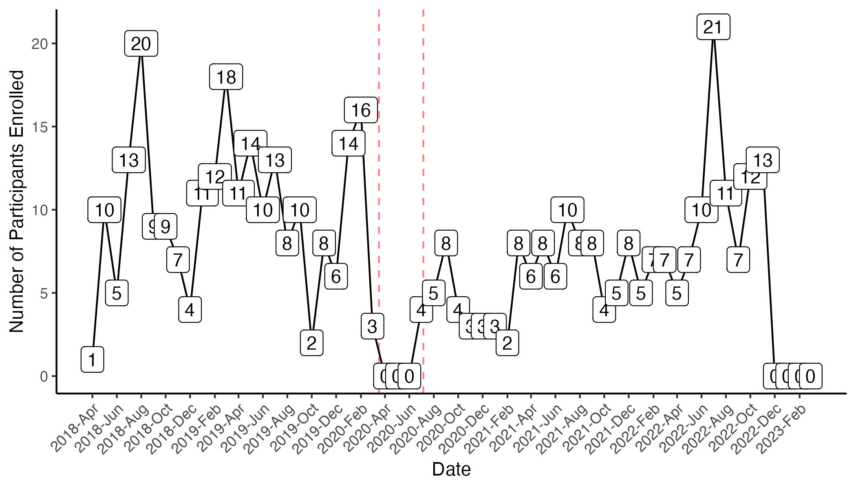

1. Recruitment began on April 17, 2018 and ended temporarily on March 17, 2020 due to COVID-19 and began again on July 6, 2020

2. Graph does not include participants that screened out during baseline assessment

Average recruitment (*2020-03-17 to 2020-07-05 not included in the denominator*):

* Overall = 8.3 per month
* Pre-COVID = 9.8 per month
* Post-COVID = 7.2 per month

**Figure 6.** Monthly recruitment stratified by year.

